PROJECT 2.1Netbeans:

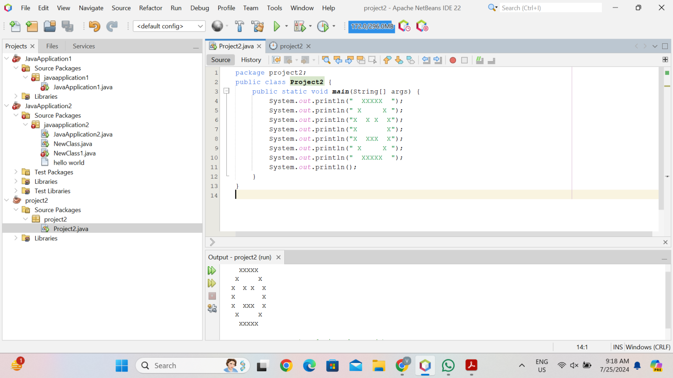

PROJECT 2.2 Eclipse:

